**Software Development and Testing IT7320**

**LAB WORK**

Team Members: Submitted to:

Anjali Khandelwal Chalinor Baliuag

Kwinno Pineda

Ralph Saplan

Thanh Huynah

Git DVCS (Distributed Revision Control) uses GitBash, a **command-line tool** to connect to your work locally and its working directory is a full-fledged repository with complete history and full version-tracking capabilities, independent of network access or a central server. (Wikipedia, 2015).

While on the other hand Github, is a web based Git repository hosting system which is free and open source used commonly with team collaborating with a project. It is a **web based graphical interface system** and desktop as well as mobile integration. It also provides [access control](https://en.wikipedia.org/wiki/Access_control) and several collaboration features such as [bug tracking](https://en.wikipedia.org/wiki/Bug_tracking_system), [feature requests](https://en.wikipedia.org/wiki/Software_feature), [task management](https://en.wikipedia.org/wiki/Task_management), and [wikis](https://en.wikipedia.org/wiki/Wiki" \o "Wiki)for every project. (Wikipedia, 2015). Github also provides private account which needed to pay only few people used it. (Wikipedia, 2015). Github use can be used remotely using Gitbash or other application (Netbeans, Eclipse and etc.)

# References

Wikipedia (2015). Retrieved from <https://en.wikipedia.org/wiki/Git_(software)>.

Wikipedia (2015). Retrieved from https://en.wikipedia.org/wiki/GitHub.

There are many ways to connect a project to Github, one of the way is using Eclipse. First install the Eclipse Mars Java IDE then after install, open eclipse and Go to Help menu. Click Install New Software.

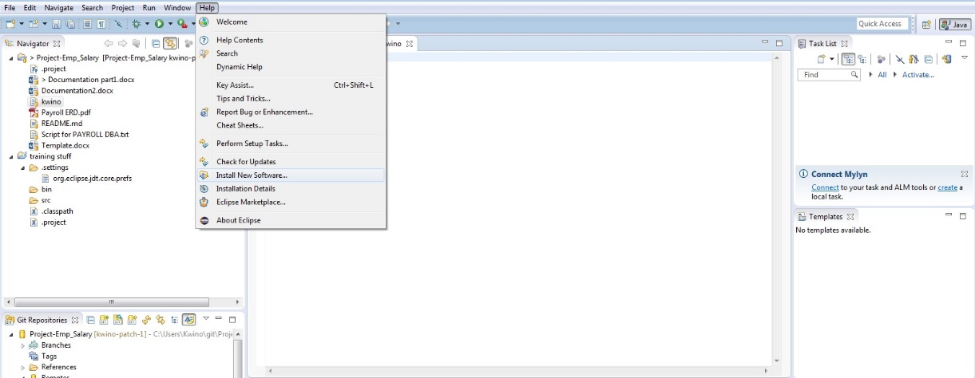

Choose <http://download.eclipse.org/releases/mars/> to download Github plugin, click Collaboration and Install all the Github plugins under Collaboration.

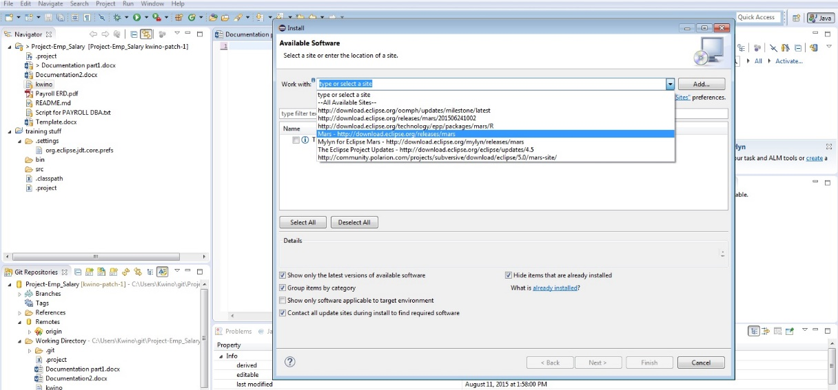

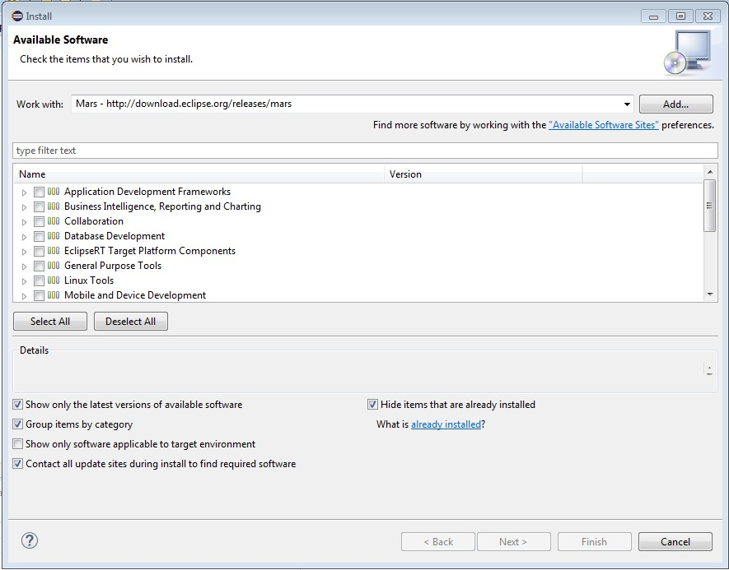

Then Go To **File Menu** select import and copy the clone in Github paste it in the URI text box. Next is select the repository you want to fetch from Github to your local computer. And select as **Import as general project**.

**Issue** is a features of Github as an integrated bug and enhancement tracker where all the things such as request, suggestion and etc. are being post as message and discuss to the group. In issue you can assigned to a specific member and put a label if it is a duplicate, bug, enhancement and others or make your own label.

You can create a **Milestone** for your issues and set the due date of your project to monitor. Creating milestone for every project is a great help all issue are being sorted or group by according to what project you are working on and all open, close of issue and completeness of the project were being recorded to display.

**Collaborators** are users who are assigned to work on a project its either same or different project, under collaborators is a feature called **team** wherein Github are included and group by to work on a same project. The administrator of the team can assigned team members what privileged he/she can use it’s either pull only, push and pull, push, pull and administrative. The administrator of the project can limit the privilege and see the information of the members without their permission.

Github tracker is called “Issues” and can be used with every repository and record to report everythings happening inside Github. Issue also